

**Experimental Lab Student Report**

Week 1 Lab

Lab Title: Hardware Components

Student Name: Anthony Meunier

Date: 1/13/2014

After completing the activities, take a screenshot of the following and copy onto this report:

1. Windows 7 users (10 points)  
   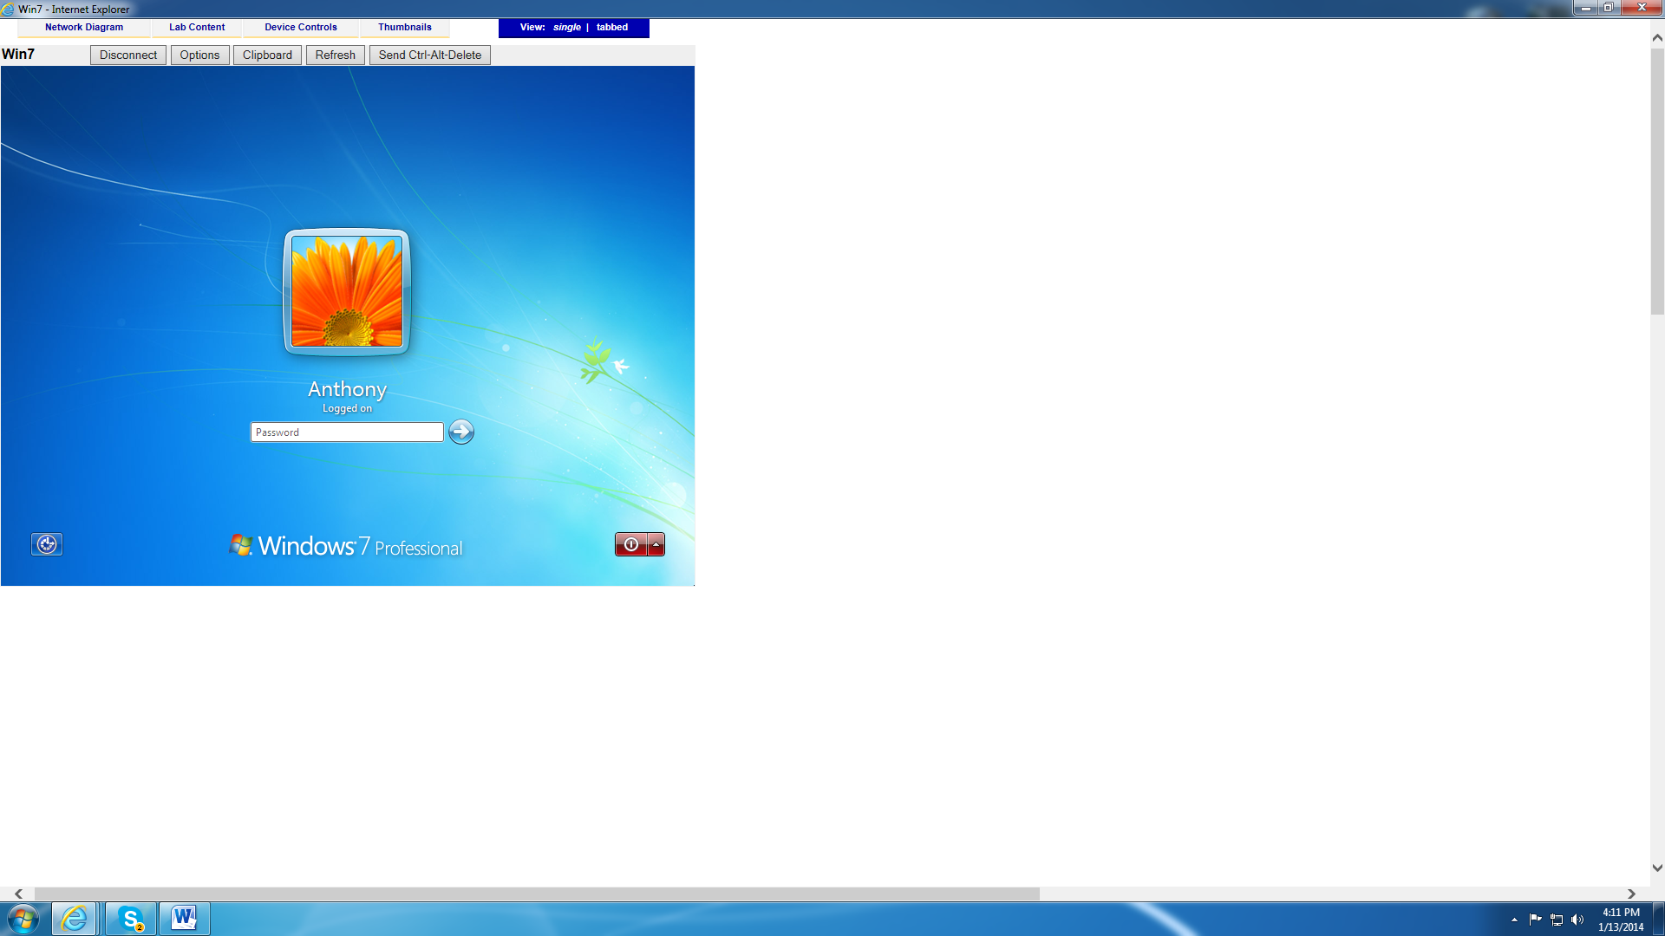
2. Fedora main screen (10 points  
   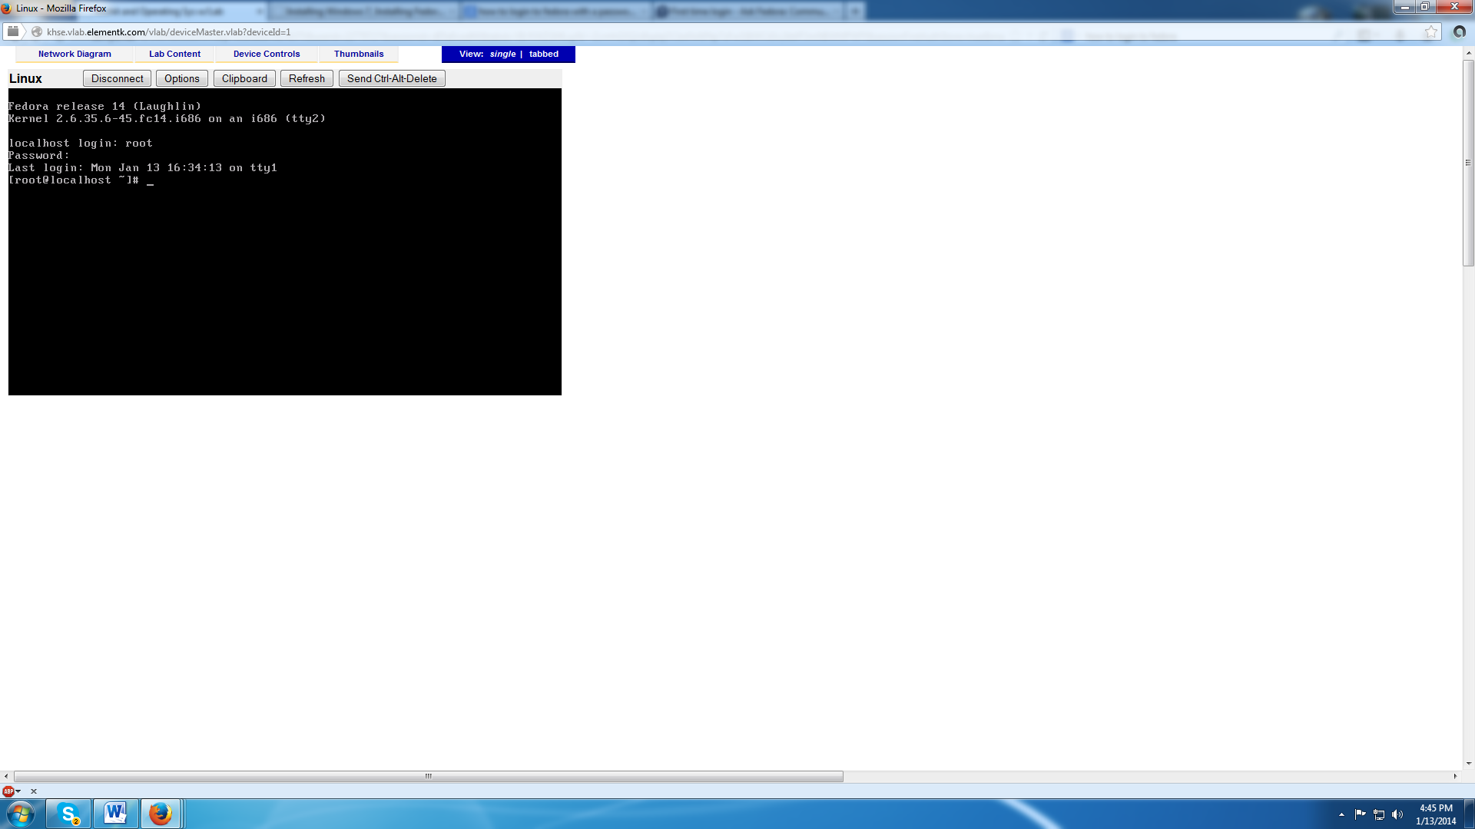
3. Activity 1-2, after #5 (10 points)

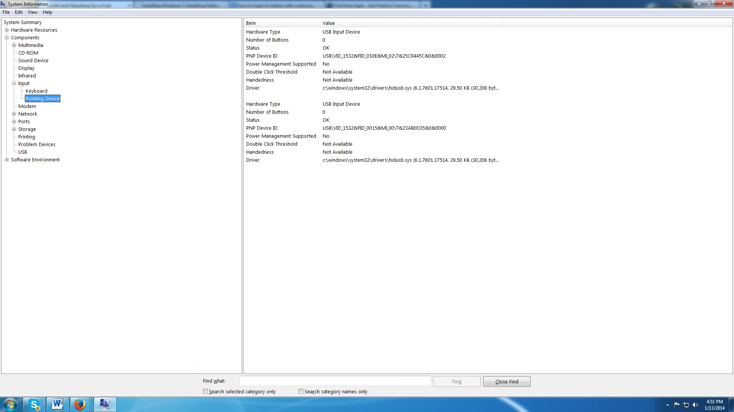

1. Activity 1-3, after #4 (10 points)

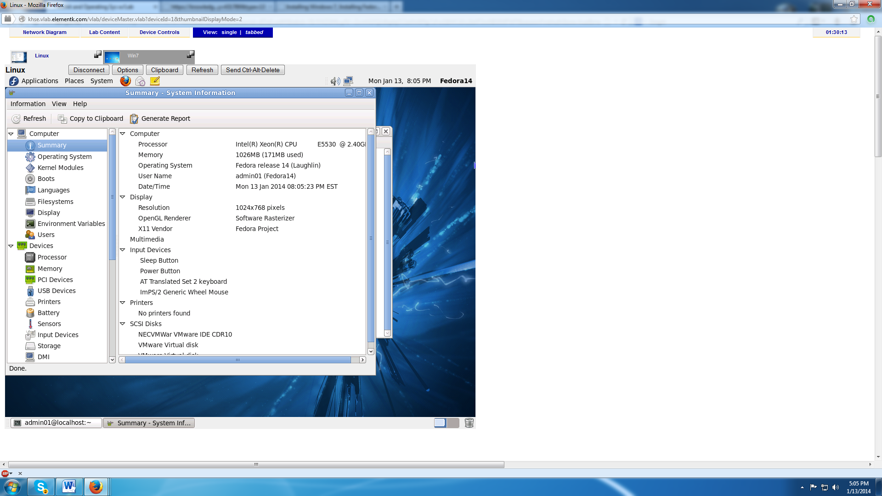

1. Activity 1-4 after #5 (10 points)

